Working with Selenium 2
practiceautomation.com
Step 1: create a maven project on terminal by typing the command mvn archetype:generate -DgroupId=com.example -DartifactId=MyMavenPracticeAutomation -DarchetypeArtifactiId=maven-archetype-quickstart -DinteractiveMode=false

Step 2 : edit the pom.xml file and add the dependencies
The pom.xml has the code
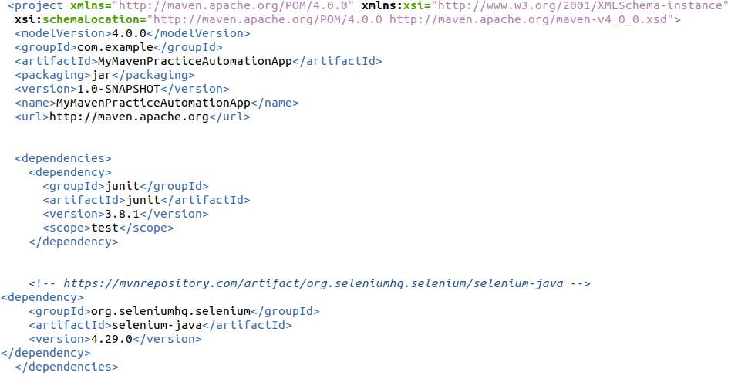
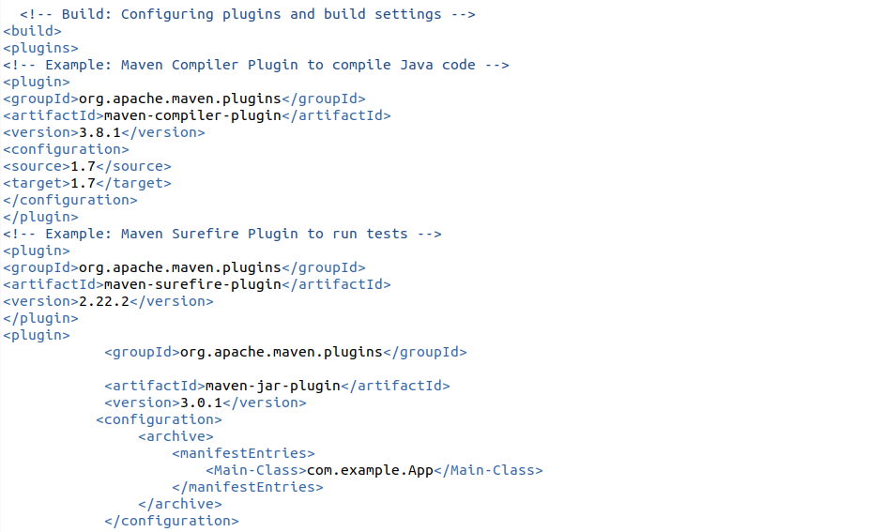
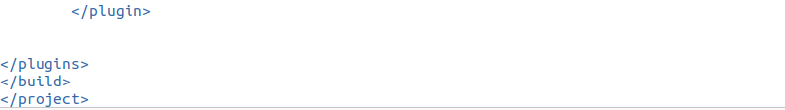

Step 3: Edit the App.java
package com.example;
import org.openqa.selenium.By;
import org.openqa.selenium.WebDriver;
import org.openqa.selenium.chrome.ChromeDriver;
public class App
{
public static void main( String[] args )
{
WebDriver driver = new ChromeDriver();
driver.get("https://practicetestautomation.com/practice-test-login/");
driver.manage().window().maximize();
driver.findElement(By.id("username")).sendKeys("student");
driver.findElement(By.id("password")).sendKeys("Password123");
driver.findElement(By.id("submit")).click();
}
}
Step 4:build and run the maven application
To execute type the command mvn exec:java -Dexec.mainClass="com.example.App"
it openspracticeautomation.com and we can login using the credentials
